Who’s Who in Canada’s Federal Government

Role | Branch of Government (from graphic on other sheet) | What they do
Monarch  (Queen Elizabeth II)  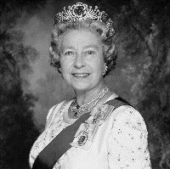 | Executive | Pg. 23  -appoints a Canadian to represent him or her in Canada. This person is called the ___________Govenor General___________________
Governor General (David Johnston)  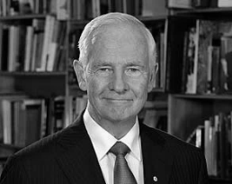 | Executive | Pg. 23  -officially appoints the _______Prime Minister________________ as Head of Government  -also officially ________dissolves________________ Parliament (which means they end the government to elect a new one)  -give ___Royal Assent_______________ to __bills__________ passed in Parliament (which means he or she is the last step in making a bill into a law)
Prime Minister  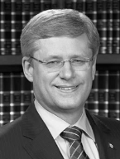  (Stephen Harper) | Executive | Pg. 28  -the __leader____________ of the political party that wins the most ______seats________ in the House of Commons  -he or she is not elected directly by the people
Cabinet  Cabinet (continued) | Executive | Pg. 28  -the ________Prime Minister_______________________ chooses members of the Cabinet  -advisors to the Prime Minister  -Those who head government departments are called ____Ministers________________ (ex: Minister of Education, Minister of Transportation…)  -The Cabinet takes ___collective responsibility_____________ for government policies  -it must __agree with________ the government’s decisions
Senate | Legislative | Pg. 24  -one of the Chambers in our government  -Senators are _____appointed__________________ by the Governor General  -it ___reviews________ and _debates_______ bills proposed by both Chambers  -bills must be passed through both Chambers--__Senate___ and _House of Commons_______________________--and be given Royal Assent before becoming law
House of Commons | Legislative | Pg. 26  -the _elected__ law-making body in Parliament (when we vote, we vote for these people)  -when MP’s (Members of Parliament) meet together in the House of Commons, we say that the House is ___in session____________________ or is _sitting____________________  -the work on an MP in the Chamber includes _reviewing____ and __debating_____ new bills that affect all Canadians  It also includes taking part in __question period______, making statements about important events and issues from the riding (the place where they were elected), raising issues and presenting ___recommendations__ and __reports____________________.

