Types of Government

Type of Government | Explanation | Type of Leader | Examples
Democracy  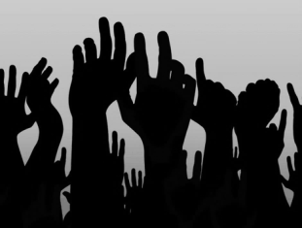 | -people run the government (or a small group)  -vote for leader  -people work together to decide things  -rights  -discussion  Problems:  -takes a long time to change laws/make laws | Democratic  -listens to people  -do what is good for the people  -works with others to make decisions | -Canada  -Czech Republic  -India
Monarchy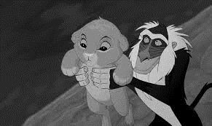 | -Decisions made by king/queen…  -born into the role (or take it)  -stay the leader for life  Problems:  -could be corrupt (stuck with them)  -possible riots/war | Authoritarian  -no input from people  -command respect (didn’t earn it)  -fear  -total control | -Saudi Arabia
Dictatorship  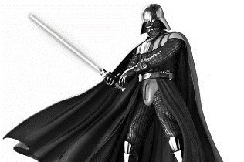 | -leader controls everything  -not elected  -harsh laws and punishments  -censorship (only allowed certain things)  Problems:  -no rights for people  -corrupt | Authoritarian  -total control  -No input from people  -military used to enforce laws  -no criticism  -many restrictions | -North Korea  -Hitler’s Germany  -Russia (Putin)
Type of Government | Explanation | Type of Leader | Examples
Theocracy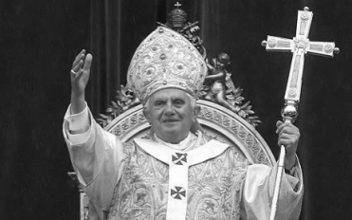 | -religious leader is the leader  -input from people, but can overrule  -voted in by only a few people  Problems:  -limit rights  -have to be that religion | Authoritarian  -total control  -command respect  -no criticism | -Vatican City  -Iran
Communism  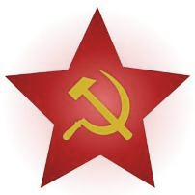 | -government controls everything, but shares it equally  -everything shared equally  -  Problems:  -limits rights  -total government control | Democratic (sometimes ends up Authoritarian)  -total control by leader  -little input from people  -military to enforce | -Cuba  -Vietnam
Anarchy  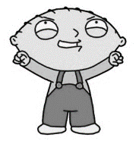 | -state of no government or no government control  -lawlessness or not enforced  Problems:  -chaos – no rights – no safety – no punishment – no control | Laissez-faire  -lazy  -relaxed  -ineffective – not good | -after a major disaster when everything is crazy  -war  -earthquake

