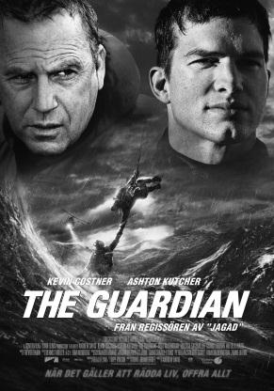
The Guardian – Viewing Notes
While you watch the film, think about a possible focus for a news article. What event specifically would you like to report on? Keep some point-form notes in the charts provided. You will need this information when you begin writing your news article.

  - Coast Guard
What is the legend of the Fisher of Men?

Describe what happens on Ben’s last Rescue Swimmer job?
- Events that take place:
- Who was involved (how many people)?
- Who survived?
- Where did this happen? (where does Ben live?)

  - Teacher
What is he training the students to be?
Describe the things Ben makes the students do as part of their training program.

How many students were kicked out of the program in the first 2 weeks?
What does Ben consider to be the most important quality in a rescue swimmer?
What is Jake Fischer’s back story?
Why is Ben a legend at the school?

  - After Jake graduates the program
Where is Jake assigned to go?
How has Ben’s opinion of him changed?

Describe what happens when they attempt to rescue the kayakers:

Describe what happens during Jake’s first rescue without Ben?

Who is the legend about? Describe what he is said to do:
  - Make a list of 3 events that you have enough information about to “report on” in your news report:

  - Choose one, and make sure you have all the lead paragraph information:
Who:
What:
Where:
When:
Why:

