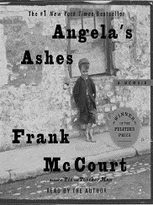
The Glass Castle – an introduction

Make notes on the following during the class discussion:

What is a memoir?

What do you infer about The Glass Castle based on the chapter titles?

Tone and examples of words to describe it:

Questions:
- Despite The Glass Castle portraying an incredibly difficult life, it is not a sad or depressing novel.
How does Walls achieve this tone? (What makes it not come across sad or depressing?)

- Provide a specific example of where the tone was unexpected.

- What word would you use to describe the tone of the novel?

- What have we learned so far about:
- Her family life (in the present)
- Her upbringing

- What issues are we introduced to so far in the novel?

- Make at least 3 predictions about where you think this is all going.

