Survivor Presentation
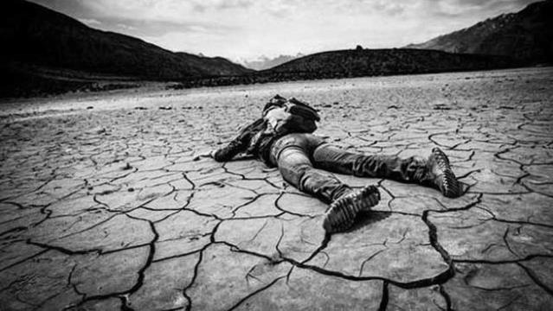
Learning Goals:
- I can summarize information so that I can convey the most important ideas to my audience.
- I can organize information effectively into a presentation so that my audience can easily follow it.
- I can create a media piece that effectively supports my presentation.
- I can clearly and effectively convey my ideas orally in a presentation.

We have looked at many stories of survival. Now is your chance to teach us about a survival story you have researched.

Find some information on one of the following survivors and create a presentation outlining what the person went through, how they survived, and what happened afterwards.
Topics:
- Bethany Hamilton – survived a shark attack
- Petra Nemcova – survived a tsunami
- Alice Jackson – survived Hurricane Katrina
- Someone who survived the 9/11 attack on the Twin Towers
- Ellie Wiesel – Holocaust survivor
- Tsutomu Yamaguchi – Hiroshima and Nagasaki bombing survivor
- Juliane Koepcke – survived a plane crash
- Jon Krakauer – survived Mount Everest disaster
- Douglas Mawson – survived Antarctica expedition
- Alexander Selkirk – castaway on an island in the South Pacific
- Lydia Marie Barragan – survived in the North after companion died
- Someone who survived a war – a specific person with a REAL survival story
- Someone from an I Shouldn’t be Alive episode – make sure it’s a full-length episode – available on YouTube

Success Criteria - Your presentation must include:
- A summary of what happened
  - Who the person is
  - How they got into the situation in the first place
  - Some obstacles they had to overcome or things they had to do to survive (5-7)
  - How they ended up being rescued or surviving
  - Aftermath – what happened afterwards
- A visual to help convey your ideas in your presentation
  - Options: short video (that is related to your presentation), an image that you will explain in detail
- A slideshow that highlights the key points of your presentation
  - Must include all sections of the research chart
  - Must be in point form and include all important information
  - Must be edited
  - Must include both images and text
- Present your slideshow and your information to the class in a 3-5 minute presentation demonstrating good use of presentation skills
  - Eye contact – clear voice – non-distracting body language –demonstrates practice

Research Chart:
Introduction:
Gather the following information from your research to introduce your presentation
Who: |  | What:
Where: |  | When:
Why:

Body:
Find out more details about what happened and summarize the event.
How did they get into this situation?
Some obstacles they had to overcome or things they had to survive (5-7):
How they ended up being rescued or surviving:
Conclusion:
Wrap up your presentation by giving us some details about what happened afterwards.
(If you have a video or specific picture to present, introduce it and show it now)
Introduction of visual: |  | Description of aftermath:
**When you’ve had your research chart checked, take this information and turn it into a slideshow
- Each box should be its own slide (the “obstacles” section could be more than one slide)
- Each slide should have at last one picture on it that helps illustrate what you’re saying
- All slides should look similar – same font, size, background colour, etc.
- PRACTICE your presentation so you know what you’re going to say!!

