Narrative Elements
Element | Definition | Examples (2)
Narrative Point of View  -First Person  -Third Person Limited  -Third Person Omniscient | First - From a character’s point of view (usually the main character).  Limited- Told from the narrator’s point of view, but focussing the narration through the eyes of a single character.  Omniscient- told from the narrator’s point of view. The narrator knows the thoughts and feelings of ALL of the characters. | First Person - I looked at the magazine. It had been opened upon a learned article by a well-known historian whose name had often been in the newspapers lately”  Third Person Limited - Detective Smith sat back in the chair, draped his laced fingers over his chest and eyed the man across the silver table.  Third Person Omniscient - He sat down next to Margie, playing with his tie to keep down his nerves. The company Margie was heavily invested in had been struggling for a while. If it collapsed, she would lose nearly a hundred million dollars. She noticed Jonathan's nervousness and frowned.
Subplot | Not part of the main storyline, but a secondary storyline in the same work. Used to emphasize certain aspects of the main storyline. | In A Midsummer Night’s Dream, the main plot line is the couples in the forest, while the subplot is the workmen trying to put on a play.
Setting  Tone  Mood  Atmosphere | Tone - The view or attitude that the author gives a specific character, place, or thing.  Mood - The feelings or emotions the reader feels from the work.  Atmosphere - The overall feeling of the work. A combination of the tone and mood. | Tone-The Road not Taken  --"I shall be telling this with a sigh/Somewhere ages and ages. Two roads diverged in a wood, and I,/I took the one less traveled by,/And that has made all the difference."-- The character is commonly interpreted as looking back on his experience with joy  Mood- “The river, reflecting the clear blue of the sky, glistened and sparkled as it flowed noiselessly on.”  Charles Dickens - Pickwick Papers. Here he the author sets a peaceful mood.  Atmosphere - It was a dark and stormy night; the rain fell in torrents — except at occasional intervals, when it was checked by a violent gust of wind which swept up the streets (for it is in London that our scene lies), rattling along the housetops, and fiercely agitating the scanty flame of the lamps that struggled against the darkness - suspenseful/fearful atmosphere  -The Matrix fight scene – suspenseful, dark, barren atmosphere
Characterization  Implicit  Explicit | Implicit - Revealing what a character is like very subtly-mostly through their actions and words.  Explicit - Telling the reader what a character is like. Usually through what other people or the narrator say about them. | Implicit - Characterizing a rich man: He chortled heartily before deeply puffing on his high end Cuban cigar, briefly glancing at his Rolex. He announced his driver would arrive at any moment and demanded the driver speed up because he was going to be late.  Explicit - Characterizing a rich man: He was very rich.
Anti-hero | A protagonist that is not typical and has the qualities of a villain, yet we are still on their side. | 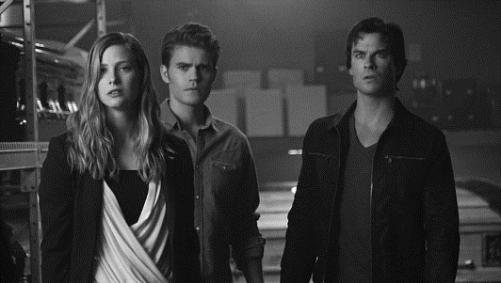  The Vampire Diaries  The protagonists are vampires but throughout the show, the audience is on their side
Conflict  Internal  External | Internal - Struggle occurring within a character's mind  - man vs self  External - A struggle between a character and an outside force such as nature or another character.  -man vs man  -man vs fate  -man vs society | Ex 1. In that 70’s show, Bob can’t decide whether he should get back with his wife who left him then came back, or whether to stay with his current girlfriend  Ex 1. In The Hunger Games, there is a constant fight with society because they are forced into the games.
Theme | The message or the moral of the story/poem/movie | The Hunger Games - Allies are important, you won’t last long if you’re on your own.
Context | The circumstance in which an event occurs, such as setting, or specific time period. This can really influence our understanding of the theme | In “The Possibility of Evil” the story is set in a small town so in order to understand it you have to have basic knowledge of small towns.

Literary Devices

Literary Device | Definition | Examples
Alliteration | The repetition of the same letter or sound at the beginning of closely connected words. | Peter Piper picked a pair of pickled peppers.  Garry’s giraffe gobbled gooseberries, greedily getting good at grabbing goodies.
Allusion | Making a direct reference to a place, person, history, piece of literature, or pop culture. Relies on the reader being familiar with this reference. | Do you even I-phone bro?  I was surprised his nose was not growing like Pinocchio’s
Analogy | A comparison between two things for the purpose of explanation or clarification. Similar to giving an example. | "I am to dancing what Roseanne is to singing and Donald Duck to motivational speeches. I am as graceful as a refrigerator falling down a flight of stairs." - Leonard Pitts, "Curse of Rhythm Impairment" Miami Herald, Sep. 28, 2009
Anecdote | A short amusing or interesting account, usually about a real event. Used to entertain or prove a point. | Ex. weight watchers commercial on tv when they have real people sharing their experiences with losing weight so that people watching can be motivated to do the same.  Ex2 – when you grandparents try to explain how much more difficult their lives were. [insert shaky old person voice here] “When I was your age, I had to walk to school uphill both ways through a snowstorm)
Archetype | A very typical example of a certain type of person or thing. Similar to a stereotype. | 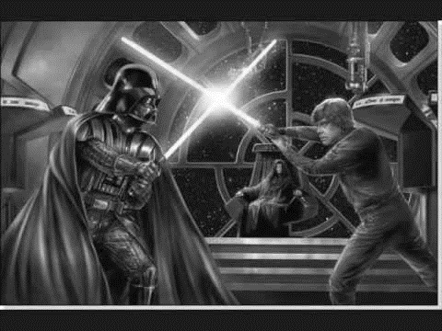  Hercules is the hero archetype (he is courageous, strong, powerful etc) and he can do no wrong.
Diction | The choice of words used to make the reader think a certain way. | Lemony Snicket and a series of unfortunate events uses a lot of very descriptive and depressing words that work well in a story of orphaned children.
Hyperbole | An exaggerated statement not meant to be taken seriously. | 1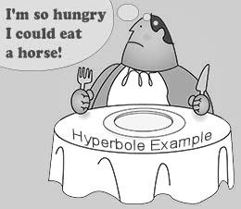
Imagery | Using descriptive words that appeal to the five senses to create an image for the reader. | A host, of golden daffodils;  Beside the lake, beneath the trees,  Fluttering and dancing in the breeze.  Continuous as the stars in the Milky Way
Irony  Situational  Verbal  Dramatic | Situational - A situation where the actions or outcome is not what was expected.  Verbal - Saying the opposite of what is meant. Usually accompanied by a sarcastic tone.  Dramatic - When the audience/reader knows something some of the actors/characters don’t. | A fire station burns down.  The marriage counselor files for divorce.  Looking at her son's messy room, Mom says, "Wow, you could win an award for cleanliness!"  Two people are engaged to be married but the audience knows that the man is planning to run away with another woman.
Juxtaposition | Placing two opposing ideas side by side to emphasize the differences. | Ex. 1 Godfather scene - flips between baptism in church and murders that he ordered  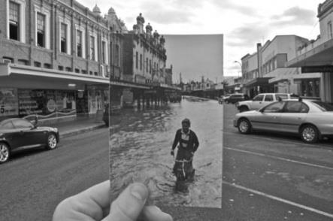
Metaphor | A direct comparison without using ‘like’ or ‘as’ to emphasize similarities or differences. | She cut him down with her words
Oxymoron | A combination of contradictory words. | Wake up dead  Sweet agony
Pathetic Fallacy | The weather or nature mirrors the action of the story. | 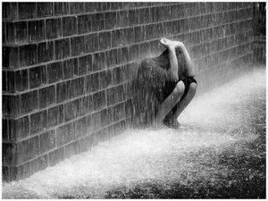  Ex 2- horror story takes place on a dark and stormy night
Personification | To give an object human traits or characteristics. | Ex 1 - The trees danced back and forth in the wind
Pun | A humorous way of emphasizing a word that has two different meanings. Usually a play on words. | “The calendar days are numbered”  Mercutio while dying – “Ask for me tomorrow and you will find me a grave man”
Repetition | Saying the same word or phrase again to amplify meaning or adding power. | Because I do not hope to turn again  Because I do not hope  Because I do not hope to turn ( T. S. Elliot)
Rhyme | When the endings of words that sound similar. | 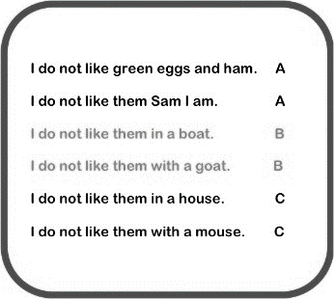
Satire | A piece of literature written in the form of a joke to make fun of it. Satire often points out flaws in politics or current events. | 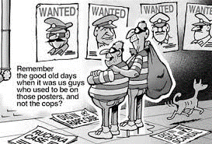
Simile | A direct comparison using ‘like’ or ‘as’ to emphasize similarities or differences. | 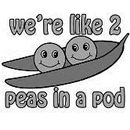  “It's been a hard day's night, and I'd been working like a dog”-The Beatles
Symbol | A thing that is used to represent or stand for something else. | 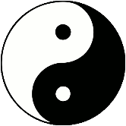  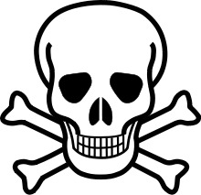
Syntax | The arrangement of words in a sentence. | 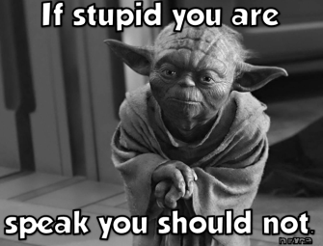  “What light from yonder window breaks” – instead of “What light breaks from yonder window”

