Narrative Elements
Narrative Element | Definition | Examples (2)
Plot Elements  -Introduction  -Inciting Incident  -Rising Action  -Climax  -Falling Action  -Resolution | 1.Introduction - Characters and setting will be introduced and a brief explanation of the story begins  2..Inciting Incident - An event which initiates conflict.  3.Rising action - Rising actions are incidents that occur to increase tension leading up to climax  4. Climax→ where the tension or action reaches its highest point  5. Falling Action - the plot after the climax has been reached and where the conclusion is resolving  6. Resolution - where the plot ends and everything is usually resolved | 1. Star wars introduction  “In a galaxy far far away…”  2. Prim is chosen for the Hunger Games and Katniss volunteers in her place  3. When Katniss is preparing for the Hunger Games in The Capitol  4. When Luke Skywalker and Darth Vader have an epic battle  5. Death star is destroyed, friends are reunited.  6. Harry Potter in the future with his family, resolving the story
Subplot | A secondary plot going on at the same time as primary plot | -The Hunger Games- Katniss’s relationships with Peeta and Gale going on while main plot is the games.  -Romeo and Juliet- Conflict between Capulets and Montagues while main plot is Romeo and Juliet’s relationship
Narrative Point of View  -First Person  -Third Person  Limited  -Third Person  Omniscient | The point of view from which the story is told.  First person:  -the narrator is talking about themselves and their experiences, using personal pronouns, I, me, we, etc.  Third person limited:  -when the narrator has an inside view but of only one person  Third Person Omniscient:  -the narrator has a general view of everyone in the story | -During English class, I borrowed a chromebook in order to do my homework.  -He thought to himself that he should borrow a chromebook to finish his homework.  -During English class, he borrowed a chromebook in order to do his homework. Sally decided to borrow one too.
Setting  -Atmosphere  -Tone  - Mood | Atmosphere-The environment of a setting. What is happening around the event physically or mentally. Has an effect on the tone and mood of the event.  Tone -The tone is the general attitude or feeling conveyed by the speaker to influence the audience  Mood-A state of mind or feeling based on the current setting and events in the story felt by the reader. | 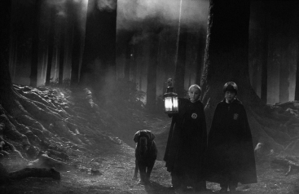  The mysterious house radiated an air of mystery, filling my chest with an anxious dread. My heart couldn’t help but skip a beat, as I gulped and opened the creaking door
Psychological Landscape | When a character’s state of mind or mental health affect how they describe to the reader what the landscape or setting is like. | I walked down the Jargon Street, the corners darker than the rest of the road. Each corner I turned was more horrifying than the last.  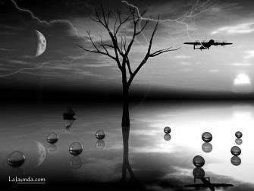  dark vs light  what character could see vs what is reality
Theme | The main idea or message – what the author is trying to convey | ex. 1 a theme of The Hunger Games is suffering as entertainment leads to rebellion
Context | Background information (prior knowledge) that explains why things happen or how they make sense | ex. 1 the author of the hunger games grew up in a military setting with her father in the military and could explain in her book more about conflicts of war and the military.  ex. 2 to understand a story set in Nazi Germany you would have to know something about Nazi Germany – Hitler, WWII, concentration camps
Conflict  Internal  External | External: Tension or incompatibility between two things or people.  Internal: When a character is trying to discover who they are or make a tough decision | 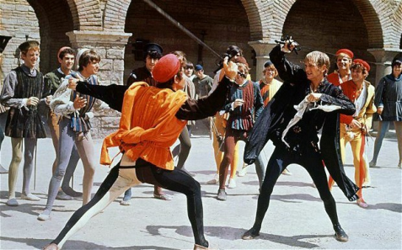  External:  Internal: internal conflict in Romeo and Juliet is when  Juliet has to make a decision between Romeo and Paris and what she is going to do about it.

Literary Devices
Literary Device | Definition | Examples (2)
Allegory | Symbols, actions or events that work to create a political, moral or spiritual message | The Wizard of Oz reflects on the politics of the time  The Chronicles of Narnia is an allegory for Christianity
Alliteration | First letter of each word is the same – don’t have to be beside each other | Slithering Snake  My Cadillac was completely crushed in a car crash.
Allusion | Reference to a place, person, historical event, piece of literature | Stacy went to the historic Arc De Triumphe  He had Herculean strength
Analogy | A similarity between like features of two things | A heart is like a pump. It draws blood in, pushes it through the chambers, and pushes through the body.
Anecdote | A short, personal, amusing or funny story usually regarding a real or serious subject | Ex. 1 “when I was young we didn’t have the internet to help us”  Ex.2 At the beginning of a speech about fire safety, the speaker tells a short cautionary tale about a serious injury that occurred as a result of not following the protocol.
Archetype | An original or perfect example of something | Ex.1 Archetype of the hero - Hercules  Ex.2 blond hair, skinny, cheerleader - archetype of high school cheerleader
Diction  -Denotation  -Connotation | Denotation is a dictionary definition of a word  Connotation is a secondary meaning of a word, ideas and feelings that are associated with the word | Denotation of a dove would be “a type of pigeon, heavy body, short legs.”  Connotation of a dove would be “ a dove implies peace”  Smell, fragrance, odour – all mean the same thing but have different connotations
Hyperbole | An intentionally exaggerated statement | Ex. “Her brain is the size of a pea”  “I’m so hungry I could eat a horse”
Imagery | Vivid and descriptive words used to describe the five senses (Sight, Touch, Hearing, Taste and Smell) | Ex. 1 I could hear the popping and crackling as mom dropped the bacon into the frying pan.  Ex. 2 A host, of golden daffodils; Beside the lake, beneath the trees, Fluttering and dancing in the breeze.
Irony  Situational  Verbal  Dramatic | Situational Irony: Irony involving a situation in which the actions result in an outcome that is different from what was intended (contrary to what was expected)  Verbal Irony: A saying used in which the context it was used in, is the opposite of the literal meaning that is usually accompanied by a sarcastic tone.  Dramatic Irony: a situation that is understood by the audience but is not understood by the characters | Situational Irony Ex:  A fire station burns down, the marriage counselor files for divorce  Verbal Irony Ex: “Oh great!! You broke my camera “  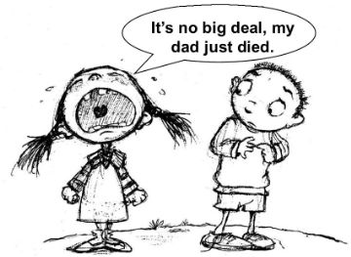  Dramatic Irony Ex: Two people are engaged but the audience knows that the man is planning to run away with another woman
Juxtaposition | Placing two opposing ideas side by side to emphasize the differences. | Ex. 1 Godfather scene - flips between baptism in church and murders that he ordered  Ex. 2  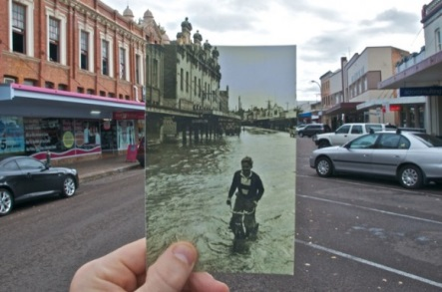
Metaphor | A phrase that directly compares unrelated ideas or terms | Ex. 1  - Firework by Katy Perry: Baby, Youre a firework come on, let your colours burst
Oxymoron | Putting two words together that contradict each other but they still make sense, usually used to describe something | Examples: awfully good, alone together, bitter sweet, dull roar, less is more
Pathetic Fallacy | Giving human emotions or attributes to nature or inanimate objects to add to the atmosphere or action (a type of personification)- it also is when the weather reflect the action in the story | Ex. 1  The angry clouds boiled on the horizon.  Ex. 2  Black clouds gathered slowly as the battle was about to begin.
Personification | Giving human attributes, mannerisms, and or emotions to other living things. | Ex. 1 – The curtain danced in the wind.  Ex. 2 – My cat looked at me questioningly.
Satire | A way of using irony, sarcasm and humor to ridicule someone and or something. | Ex. 1 – in Animal Farm, George Orwell criticizes the Russian Revolution  Ex 2:  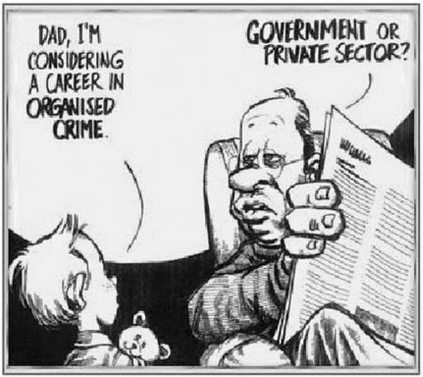
Simile | A figure of speech comparing the similarities of two different things. Unlike a metaphor it uses “like” or “as” | Ex. 1 peanut butter is smooth like Nutella.  Ex. 2 – my grandpa walks as slow as a turtle  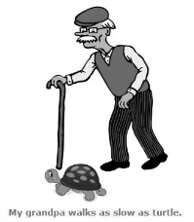
Symbol | The act of using an object to represent an idea | Ex. 1 Rose representing passion  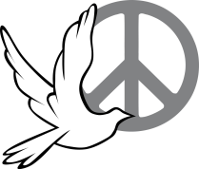
Syntax | The formation of sentences that does not follow the way we normally speak | Ex. 1 Shakespeare did not follow the language rules of his time in his plays. “Love looks not with the eyes”  Ex. 2 Yoda from Star Wars does not follow language rules when speaking.

