ANALYSIS

Missing, murdered aboriginal women crisis demands a look at root causes

Roxanne Isadore was already a survivor by the time she reached her sixth birthday.
"She used to scream at night … 'That guy is after me.'" Her grandmother Angeline recalls how the sexual abuse Roxanne experienced as a child haunted her for years.
As she got older, she continued to struggle. There were suicide attempts, addictions. And when she was 24, she disappeared.
Roxanne is one of hundreds of missing or murdered indigenous women in Canada. Women who were born into lives that forced them to fight for survival in communities rife with poverty, trauma, abuse and, inevitably, violence.
Individually, their stories are tragic and heartbreaking. Collectively, they are horrifying.
A CBC News database launched earlier this week found more than 230 indigenous women across Canada whose deaths or disappearances are unsolved.
We interviewed 111 of their families and told their stories. Not just about the death or disappearance of a loved one, but who she was and how she lived.
Each one of those women is unique, each story is gut-wrenching. Yet reading these profiles together, you begin to see patterns emerging. The underlying causes associated with missing or murdered indigenous women become hard to ignore.
Although their stories are different, the similarities arise again and again. Abuse, trauma, child welfare, addictions. And almost always, poverty.
The harsh reality is that the murdered or missing indigenous women are not the only victims. Look to Canada's jails, homeless shelters and hospitals to see others.
Aboriginal women make up nearly 34 per cent of all female prisoners in Canada. And there are more indigenous children in care now than during the height of residential schools.
That can be traced back to colonization and policies rooted in assimilation, says advocate and lawyer Christa Big Canoe.
"We have to contextualize everything. We have to look at the history and roots of institutionalization of aboriginal people in this country, including things like residential schools, the '60s Scoop and, most importantly, the criminalization which has incarcerated a lot of people in our communities," Big Canoe said.

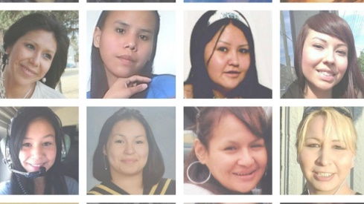
CBC tells the stories of 230 women who have gone missing or have been found murdered, including interviews with 110 families. (CBC)

