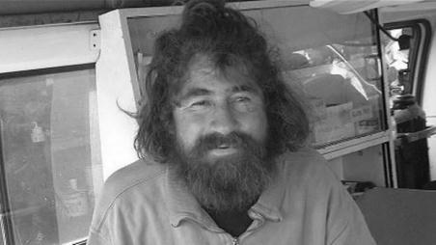
Man says he ate fish, birds and turtles as he drifted for 13 months across the Pacific Ocean
Nick Perry
Wellington, New Zealand — The Associated Press
PublishedMonday, Feb. 03 2014, 5:20 AM EST
Last updatedTuesday, Feb. 04 2014, 12:33 PM EST

It’s a story that almost defies belief: A man leaves Mexico in December 2012 for a day of shark fishing and ends up surviving 13 months on fish, birds and turtles before washing ashore on the remote Marshall Islands some 5,500 miles (8,800 kilometres) away.
But that’s the story a man identifying himself as 37-year-old Jose Salvador Alvarenga told the U.S. ambassador in the Marshall Islands and the nation’s officials during a 30-minute meeting Monday before he was taken to a local hospital for monitoring. Alvarenga washed ashore on the tiny atoll of Ebon in the Pacific Ocean last week before being taken to the capital, Majuro, on Monday.
“It’s hard for me to imagine someone surviving 13 months at sea,” said Ambassador Tom Armbruster in Majuro. “But it’s also hard to imagine how someone might arrive on Ebon out of the blue. Certainly this guy has had an ordeal, and has been at sea for some time.”
Other officials were reacting cautiously to the Spanish-speaking man’s story while they try to piece together more information. If true, the man’s ordeal would rank among the greatest tales ever of survival at sea.
Armbruster said the soft-spoken man complained of joint pain Monday and had a limp but was able to walk. He had long hair and a beard, the ambassador said, and rather than appearing emaciated he looked puffy in places, including around his ankles. Otherwise, he added, Alvarenga seemed in reasonable health.
Armbruster, who speaks Spanish, said the survivor told the following story:
He’s a native of El Salvador but has lived in Mexico for 15 years and fishes for a man he knows as Willie, catching sharks for 25 pesos ($1.90) per pound.
On Dec. 21, 2012, Alvarenga left Mexico in his 23 foot (7 metre) fiberglass boat for a day’s fishing, accompanied by a teen he knew only as Ezekiel, who was between 15 and 18.
A storm blew the fishermen off course, and soon they were lost and adrift.
“He talked about scooping up little fish that swam alongside the boat and eating them raw,” Armbruster said. “He also said he ate birds, and drank birds’ blood.”
After about a month, Ezekiel died, the survivor told officials.
Alvarenga also talked about eating turtles. Once near Ebon, he swam ashore.
“He thanked God, initially, that he had survived,” the ambassador said. “He’s very anxious to get back in touch with his employer, and also with the family of Ezekiel. That’s his driving motivation at the moment.”
Armbruster said the man said he had no family in Mexico but he does have three brothers who live in the U.S., although he could not immediately provide officials with contact details.
Gee Bing, the acting secretary of foreign affairs for the Marshall Islands, said he was somewhat skeptical of Alvarenga’s account after meeting with him Monday.
“It does sound like an incredible story and I’m not sure if I believe his story,” Bing said. “When we saw him, he was not really thin compared to other survivors in the past. I may have some doubts. Once we start communicating with where he’s from, we’ll be able to find out more information.

Questions:

Fill in the details for each part of the news report structure.
Headline:

Lead paragraph

Who –

What –

Where –

When –

Why –

Body paragraph
List 3 important details –

What is some of the background information provided? –

Copy down 2 eye-witness quotations –

List any extra information that’s not crucial to the story, but is interesting –

Concluding Paragraph
Describe how the article ends –

Video question:
It is stated that some people are skeptical about his story. Do you believe his story? Explain your answer using the following questions to guide you:
If you believe him – why? What about this story makes it believable? Use 3 specific details from the article.

If you don’t believe him – why? What about this story is unbelievable to you? Use 3 specific details from the article.

