Making your own Federal Bill Assignment /27

Step 1 – choose an issue
Choose an issue you think should be changed (see the “Passing Bills and Making Laws” handout for ideas).
My Issue: __________________________________________________________________________________

Step 2 – where will you introduce your bill? /2
House of Commons  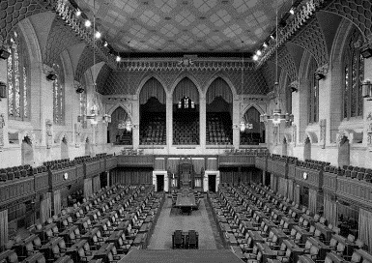 | Senate  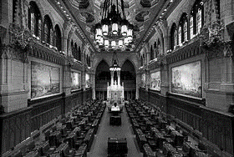

Step 3 – Introduction and First Reading
Formally introduce your bill to the house you have chosen. State the idea you want to make into a law below:
(ex: Public washrooms will be clean all the time.)
My proposed bill: ___________________________________________________________________________
__________________________________________________________________________________________

Step 4 – Second Reading /7
Members of the house debate the strengths and weaknesses of the bill.
Strengths | Weaknesses

They then vote on the bill – did it pass your vote? (it must pass to move on) __________________

Step 5 – Committee /4
Now that the bill has passed, you get a chance to look closer at it in Committee. Add 3 sentences to your original bill to make it more detailed:
(ex: They will be cleaned after 2 uses. There will be hand sanitizer outside the washroom.)
2 sentences added: __________________________________________________________________________
______________________________________________________________________________________________________________________________________________________________________________________________________________________________________________________________________________

Step 6 – Report /2
The Committee sends a Report back to the House and they add more changes. Add 1 more sentence to your original bill.
(ex: There will only be paper towel, no hand dryers.)
____________________________________________________________________________________________________________________________________________________________________________________

Step 7 – Third Reading /5
With all the changes, the House now debates the strengths and weaknesses again. Consider all the things you’ve added, what are the strengths and weaknesses now?
Strengths | Weaknesses

Now they vote on the bill again. Did it pass? _____________________

Congratulations! Your bill has passed one House. Now it needs to go to the other house to go through the same process.
My bill will now go through ___________________________________________________________________.

All 6 steps are repeated in the next house. Put the steps in order: /6
Third Reading  Committee  First Reading  Introduction  Second reading  Report | _______________________________________________________  _______________________________________________________  _______________________________________________________  _______________________________________________________  _______________________________________________________  _______________________________________________________

Congratulations! Your bill has passed the second House.

Now your bill needs Royal Assent from ___________________________________________________/1
Write out your completed bill with all the changes below (4 sentences):
_________________________________________________________________________________________________________________________________________________________________________________________________________________________________________________________________________________________________________________________________________________________________________________________________

