Levels of Government
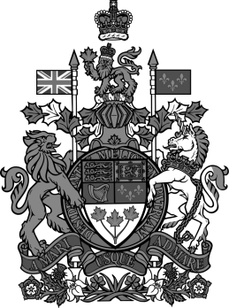
Federal Government – whole country – big things
Who’s Involved | What they’re in charge of
Prime Minister  Cabinet  Members of Parliament (MPs)  Senators | - Citizenship  - Policy with other countries  - National defense (army)  - Money and making money  - Banking  - Postal service
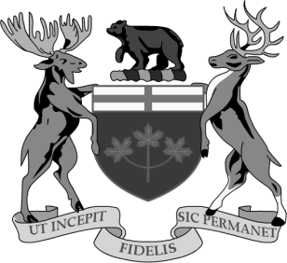
Provincial Government – provinces and territories (Ontario) – big things for province
Who’s Involved | What they’re in charge of
Premier – leader of the party who wins the provincial election  Cabinet Ministers – people the Premier appoints  Members of Provincial Parliament (MPPs) – people elected locally to represent their riding in Provincial Parliament | - Health care  - Child welfare  - Highways  - Labour (employment)  - Property rights  - Education

Municipal Government – city or township
Who’s Involved | What they’re in charge of
Mayor – person who wins the local election  Councilors – in charge of certain areas | - Varies from province to province  - Local fire and police services  - Libraries  - Transportation (buses)  - Local health issues  - Laws passed here called bylaws (parking on streets)

Using your chart, fill in the answers below:
Who’s involved:
- Who runs the municipal government? ___Mayor____________________________________________
- Who runs the provincial government? ________Premier_____________________________________
- Which group of people do we vote for in a Provincial Election? __MPP______________________________
- Who does the Premier appoint to help him or her? _______________Cabinet Ministers_____________
- Who helps the mayor make decisions about the city? ____________Councilors_______________________

What they’re in charge of:
Who’s in charge of:

- Health care? ____Prov_________________
- Buses? _____________Mun___________
- The Army? ______________Fed_________
- Citizenship?_______Fed_______________
- Highways?___________Prov___________
- Postal Service?___________Fed________

