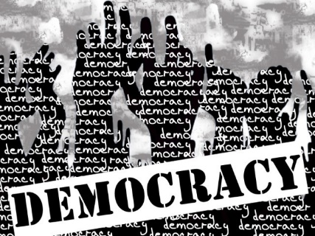
Democracy: Your Understanding

Definition:

OR -

Where does democracy exist?

Brainstorm what you think concepts/beliefs/values of living in a democratic society are:
4 Key Elements:

Democracy Pros and Cons:

Comparing forms of government:
“Life in France” clip |  | “Kingdom of Bhutan” clip
List the good things in France’s democracy: | How does this compare to Canada? | List the things that prove these people are happy with their government: | Which system of government is better? Why?

Your Turn:

Consider everything we’ve talked about so far and everything you’ve seen in the video clips.

- Create list of things needed for the ideal democratic society and reasons why this would create the perfect democracy.
Things needed: | Reasons why:

- Create your own constitution. Include the top 10 important things for your country using ideas from the video clips and your own experiences.

We the people of ___________________________ declare that every person
is entitled to the following:

