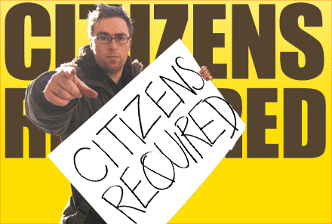
How to start your own Country

Danny Wallace set out on a mission to start his own country. He knew it would be difficult, but had no idea how hard it might be. In this series, he finds a region, declares himself King Danny, gathers citizens, and forms a government…all from his flat in England.

While watching the episode, make notes about the difficulties he faces and what he learns while trying to form a government:

Pub scene
King Danny finally hears from his people. What types of things do you need to make a country?

Meeting Prince Giorgio
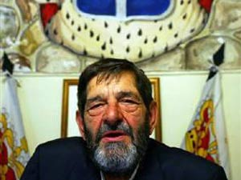
What advice does he get on how to lead his people?

What did he learn about handling mistakes?

Visiting Noam Chomsky
What advice did he give Danny about leadership?

Constitutions:

List 3 things he learns about constitutions:

List 3 things he intends to put in his constitution:

He learns that a good government is one where “The State is the servant of the people”—what does this mean?

What are the positive sides of a constitution?

