The Development of Democracy

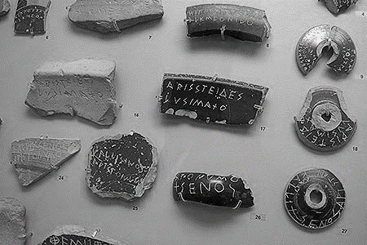

**Ancient Athens**

- First democracy

- All ___________________ involved

- Citizens = only _______________ born in Athens (no women or foreigners)



**Rome, Italy**

- ____________________

- __________________ (small number) ruled over common people (many)

- Common people rebelled and __________

____________________ – people had a say in the republic

- Only ________________ again

**Magna Carta - 1215**

- England = ___________________

- Divine right of _______________

- Series of _______________________________ between the king and his people – to stop him from abusing them

- Beginning of our _______________________ Democracy

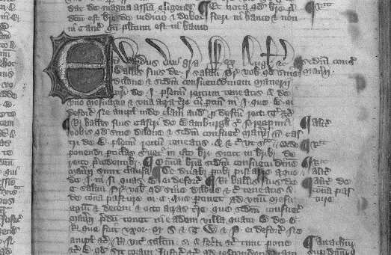

**American Revolution - 1781**

- Americans could _______________

- Government kept in check because it had _________

______________________ – if one got too powerful, the other 2 could override it

- Women and slaves = _______________



**United Nations – Universal Declaration of Human Rights - 1948**

- Human beings have a right to live and work without _________________ governments

- All people are born ____________ and _______________, and that all have the right to ___________, ________________ and the security of person

