Coach Carter Movie – Overcoming Challenges
Part A – Reflecting on the movie:
What challenges did each of the following characters face in the movie?

Characters: | Challenge: | How did he overcome it?
Kenyon Stone
Damien Carter
Worm
Timo Cruz
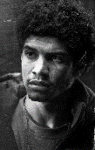
Junior Battle
Jason Lyle
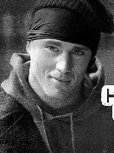
Coach Ken Carter
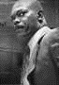

What lessons can we learn from this movie? Try to come up with 3.

Part B – Opinion Paragraph Outline:
Answer the following question in a properly structured paragraph:
What is the best way to overcome a challenge? Include:
- 1 example from the story
- 1 example from your life
- 1 example from the media (news, TV show, movie)

Planning:
Main idea with 3 points:

1 example from Coach Carter:

1 example from your life:

1 example from media (news, TV shows, movie):

Paragraph Checklist
Go over this checklist before submitting your paragraph:
- First sentence is indented  - Topic sentence includes a clear argument  - 3 points listed  - transition and your first point  - example of your first point with an explanation  - another transition and your second point  - example of your second point with an explanation  - another transition and your third point  - an example of your third point with an explanation  - concluding sentence that sums up your argument | Spelling and Grammar:  - proper spelling  - capital letters at the beginning of every sentence and on proper nouns  - periods at the end of every sentence

