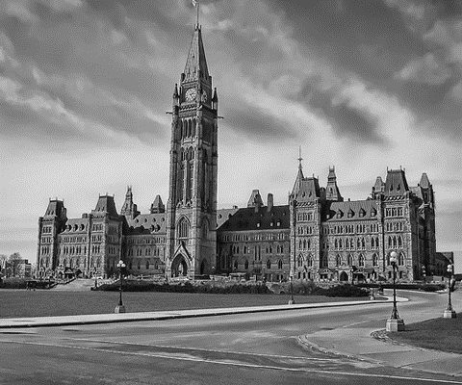
How Did Canada’s Democracy Come to Be?

BNA Act (1867) – British North America Act
- Confederation
- Our first constitution
- Created by England and Canada (so still a lot of British input)

Statute of Westminster (1931)
- British Law that gave its colonies full legal freedom
- Canada could choose to go to war with Britain
- Gave Canada more autonomy (create own laws and govern themselves)

Charter of Rights and Freedoms (1982)
- Bill of Rights
- Guarantees political and civil rights to Canadians
- With BNA Act = Canada’s constitution

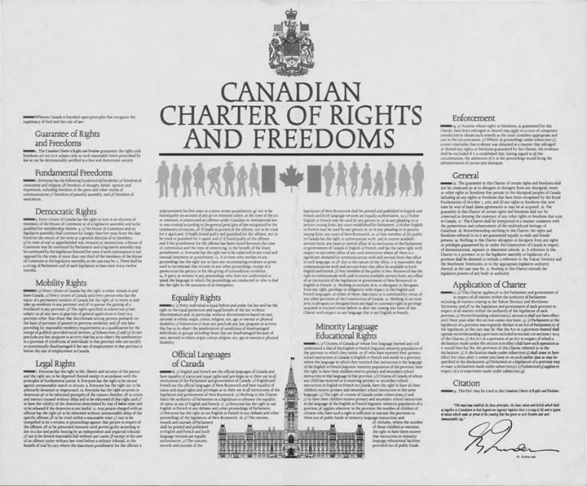
What Rights do we have as Canadian citizens?
-voting – freedom of speech – free healthcare – free education – travel in Canada – leave Canada – freedom of opinion – freedom of expression – need reasonable cause for arrest -

The Canadian Charter of Rights and Freedoms

Democratic Rights  -keep Canada a democracy | Fundamental Freedoms | Mobility Rights  -can move around in Canada
-right to vote  -elections every 5 years  -Parliament meets at least once a year | -speech - expression – opinion – to education (up to grade 12)  -religion –  - freedom of press (media)  -freedom of peaceful assembly (protest) | - can enter, remain in, or leave Canada freely  -work in any province

Legal Rights  -life, liberty, and protection | Equality Rights  -everyone equal under law | Official Language Rights  -English and French equal | Minority-language Education Rights  -Publics schools in both languages
-know the reason for arrest  -fair trial  -right against unreasonable search and seizure | -no discrimination against race, religion, gender, age, mental/physical ability | -government has to be English and French  -signs  -labels | -French and English schools available – where numbers are high enough

In each scenario, which section of the Charter has been violated?

