Bill C-51 and the Charter
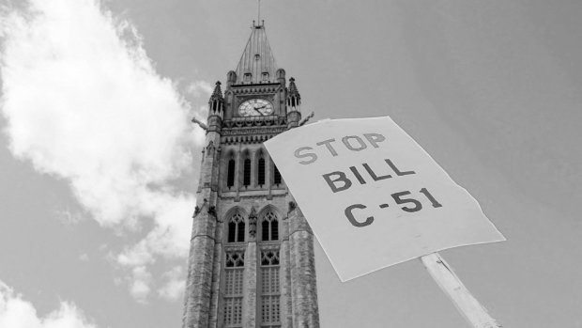
What happens when a government needs to keep its people safe? Sometimes they have to limit rights to do so.

Bill C-51, or the Anti-Terrorism law, has been introduced as necessary to keep Canadians safe. There are many potential benefits to this law:
- The government would be able to disrupt a terrorist plot BEFORE it happens
- Could stop people in Canada from committing terrorist acts overseas
- They could also monitor those suspected of terrorist ideas and keep Canadians safe.

But, some people think it could limit the rights of ALL Canadians. Here are some of the problems people think it could create:

Potential issues:
Issue | Right it could limit | Why this could be a problem
Preventative arrests - no crime committed yet, but could be arrested on suspicion of terrorism and property could be searched | -freedom of speech  -mobility rights  -legal rights  -equality rights
Ban promotion of terrorism – definition of this is very wide | -fundamental freedoms (speech) – invasion of privacy  -legal rights  -equality rights
Sharing of information between government departments – even health and income tax | -privacy – fundamental freedom  -equality rights  -democratic rights
Increasing the No-fly list – can stop people from leaving Canada if suspected of terrorist ideas | -mobility rights  -fundamental freedoms | -limits their freedom and they haven’t done anything yet

- Which 3 rights do you think are the most important?
- Should the government be able to limit rights to protect people? Explain why.

