Active Citizenship
What does it mean to be an active citizen?

What happens when you have a corrupt government, or a government who is attacking a certain group of people?
3 Types of Citizens:
The Activist - someone who actively ____________________ against the ________________________ and
their ________________________
The Bystander - someone who _________________________and lets it all happen because they don't want to
be _________________________
The Perpetrator - someone who is ______________________ the bad things and ____________________ the
government
Examples
Activists | Bystanders | Perpetrators
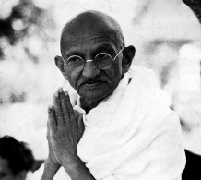  Mahatmas Gandhi  - India 1930  - brought independence to India  - non-violent action  - mass ______________________  __________________________  - hunger strikes  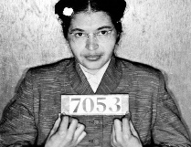  Rosa Parks  Alabama - 1955  - Parks, an African American woman, ____________________ to give up her bus seat to a white man  - set in motion Dr. Martin Luther King Jr's _____________________  _________________________ bus boycott | German people during the Holocaust - 1939 – 1945  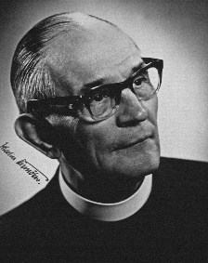  - Martin Niemoller  The Sudan – 1993  - ___________________________  ____________________________  - took his picture, won Pulitzer Prize for photography  - questions raised about what happened to the girl afterward, and he didn't know - didn't help her | Irma Grese - The Holocaust  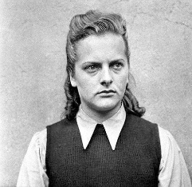  - extremely __________________ towards women in concentration camp  - captured and _______________ during Nuremburg Trials after war  Adolf Eichmann – The Holocaust  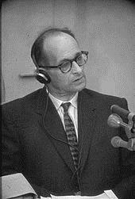  - came up with the idea of how to ____________ people during the Holocaust  - __________________________ for killing so many

